# 3. Methods and Results

## 3.1 The trend and change during the past 14 years

In this part, we mainly want to figure out the basic trend of game market using the total amount of new releases per year. And we are also interested in the price change during the past 14 years. Unfortunately, we found that although each game has a unique ID, it is still impossible to open each game page to scrap the release time and price. We finally decided to move to the third-party website Steamspy, which classify games by release time from 2008 to 2021.

On the following Steamspy web page, we found useful data. All games released in 2021 are listed, with game name, release date, release price, how many people own this game on steam, time spent in the game in the last 2 weeks, and publisher name.

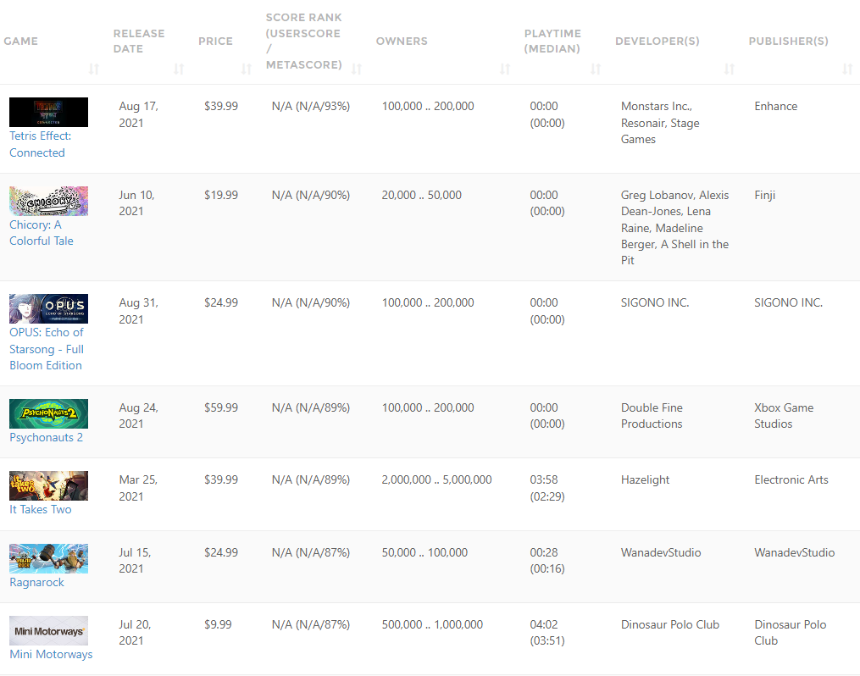

We use requests to get the content, and BeautifulSoup to make it tidy and readable. All the data we need are stored under <tdody>, so we use the function “.find” and “.find_all”. It is easy to get the game name, date, price, playtime, because these variables connected with CSS class, like {'class':'treleasedate'}. For publisher name, a slice operator helps us to get the text under the 9th <td>. Each string is stored in the respective lists by using a for loop. Pandas also helps a lot. We put all the lists we need in a dictionary and export it in CSV format. We get all the games released in 2021, and change the URL suffix to get the same data in other 13 years.

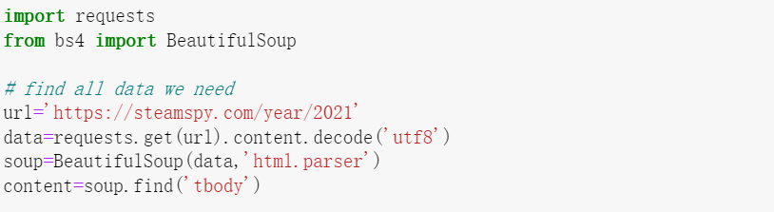

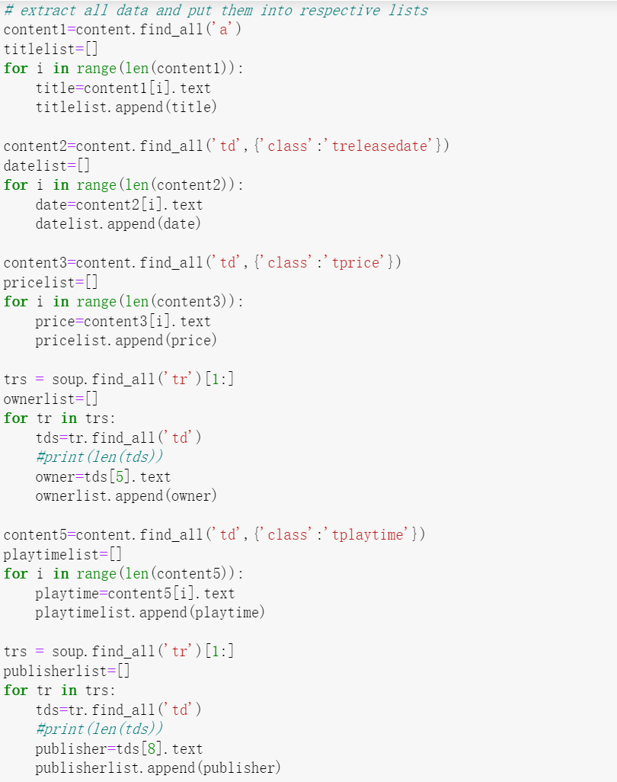

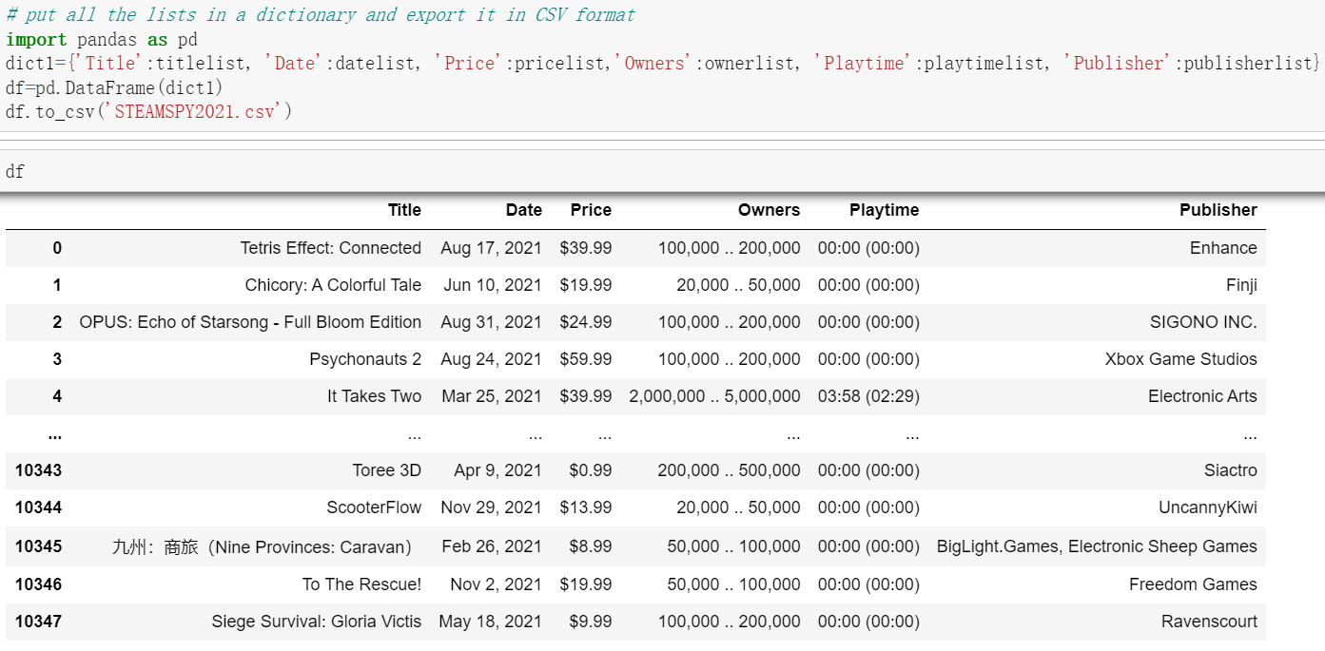

As we can see, in the playtime column, the average time and median time are stored in one single string. We use Excel tool to split it and just keep the average playtime in the last two weeks.

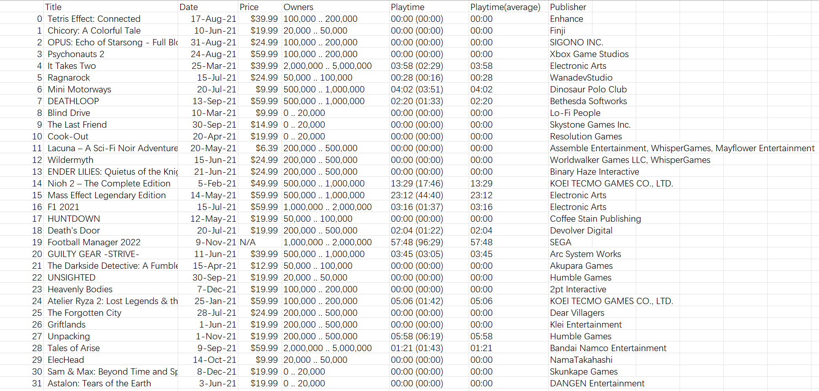

As for data visualization, we use Excel to present column chart and line chart.

**Figure 1**

*The amounts and average price of new releases in past 14 years*

As we can see, the game industry has experienced rapid development since 2014. The game market continues to expand. Except for a slight decline in the amounts of new releases in 2019, the rest continue to grow steadily every year. In 2021, more than 10,000 new games were released on Steam.

After reaching its peak in 2013, the average price of games began to decline. In the past three years, it has stabilized at around $8.75. However, due to the increase in the total amounts of new releases, the decline in the average price may be caused by the expansion of the denominator. Therefore, we counted the amounts of games with release price greater than $8.99 and their proportion in annual new releases.

**Figure 2**

*The amounts of games with release price greater than $8.99 and their proportion in annual new releases*

The proportion of games with a release price greater than $8.99 is decreasing, but the amounts is actually increasing, which means the average price calculated based on all games, to some extent, lacks reference value. If we want to know more about players' payments, we need more data, which is only available for Steam itself.

When we analysis the database we got, we also found another interesting column, average playtime in the last two weeks. We selected games with more than 10 million players and then sorted these games in descending order of playtime. We can see that free games rank higher overall on this list. While no game released before 2011 appeared on this list, we were surprised to find 5 games released in 2013 and 5 games released in 2017 on the list.

**Table 1**

*Games with more than 10 million players*

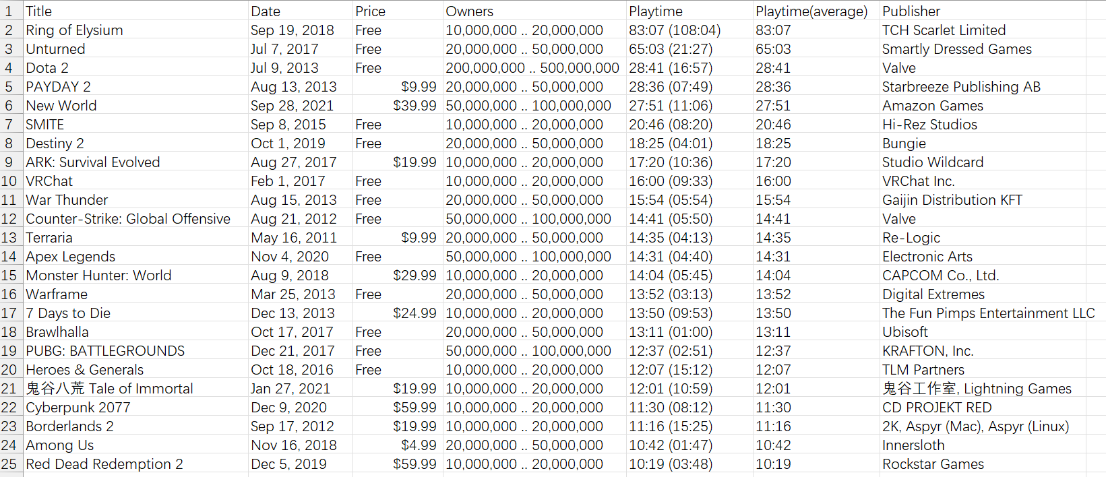

As for game publishing, we selected several well-known game publishers to observe the changes in the number of games they released on Steam in the past five years.

**Figure 3**

*The amounts of games published by different companies*

The number of games released by Paradox Interactive and 2K has not fluctuated much. Ubisoft has gradually reduced the games released on Steam until 2021 when it terminated its partnership with Steam. Most of the time, SEGA is the publisher with the most games, except for being surpassed by Electronic Arts in 2020.

## 3.2 Popular games in China and region differences in game preferences

The red square part is what we scraped, from top1~100. The good thing is, when we try to get the information of other regions and time period, we may simply need to edit the back end of this link. For example, we can change it into US, 2019, etc.

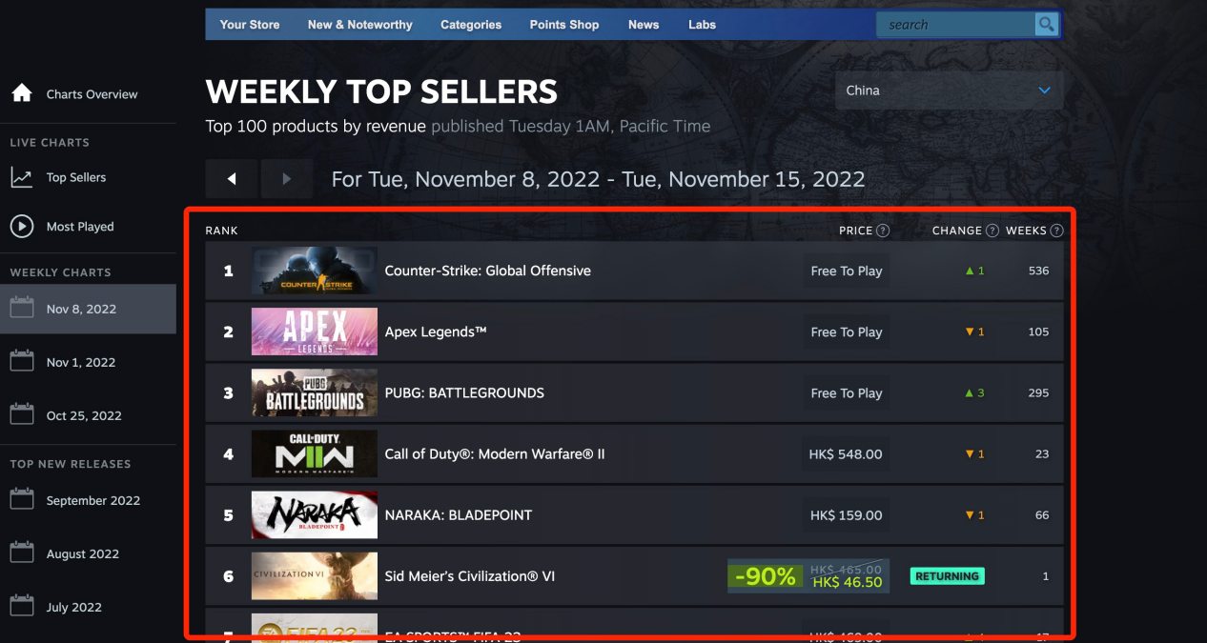

Now let’s see how the scraping is done. We first import webdriver from selenium, then to pop out our target link via the chromedriver. Then, Press FN+F12 to open the console.

By checking the elements from the table, we will be able to know all these information is contained in a tbody. Then we right click here and to get the full XPATH.

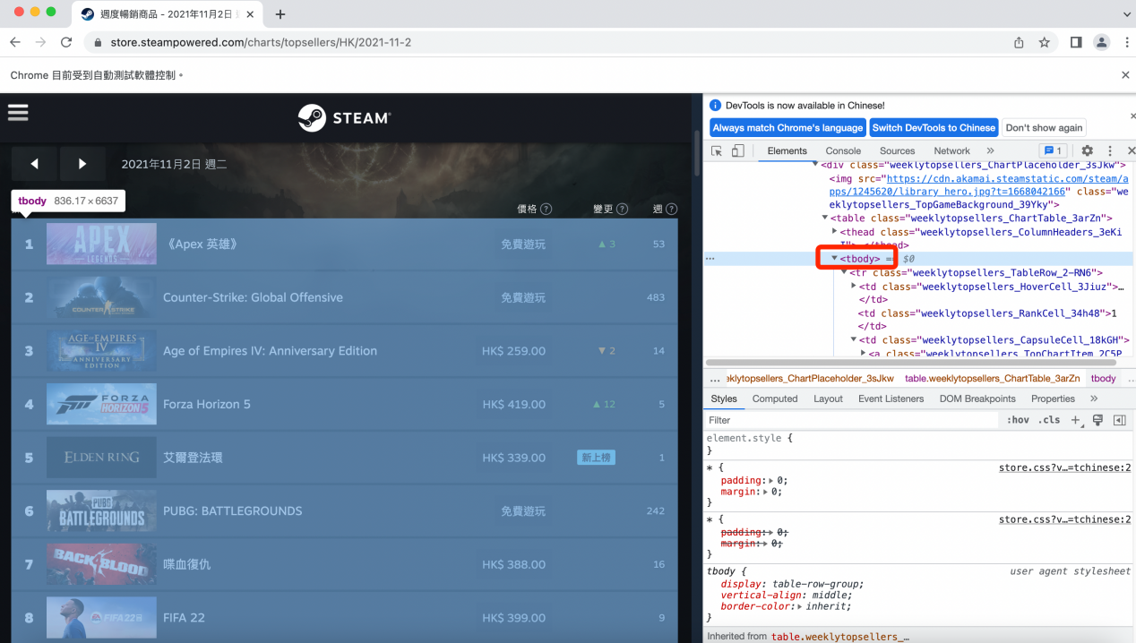

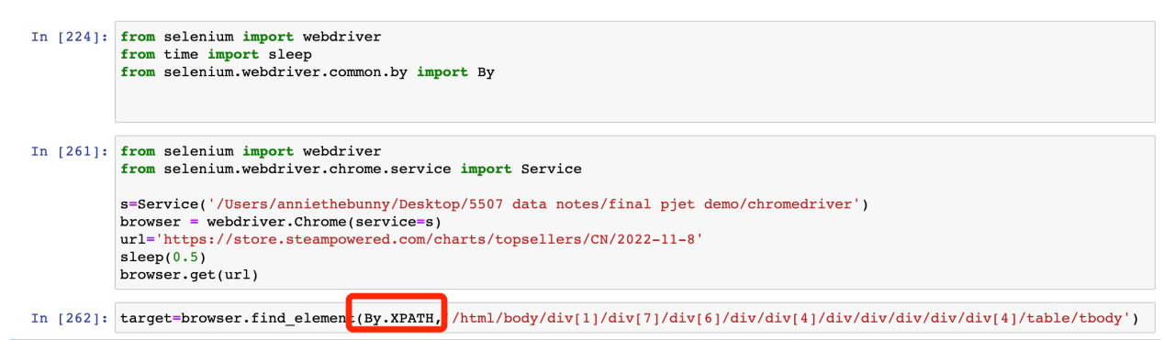

Then the XPATH would be pasted here to achieve all the content we want to scrape.

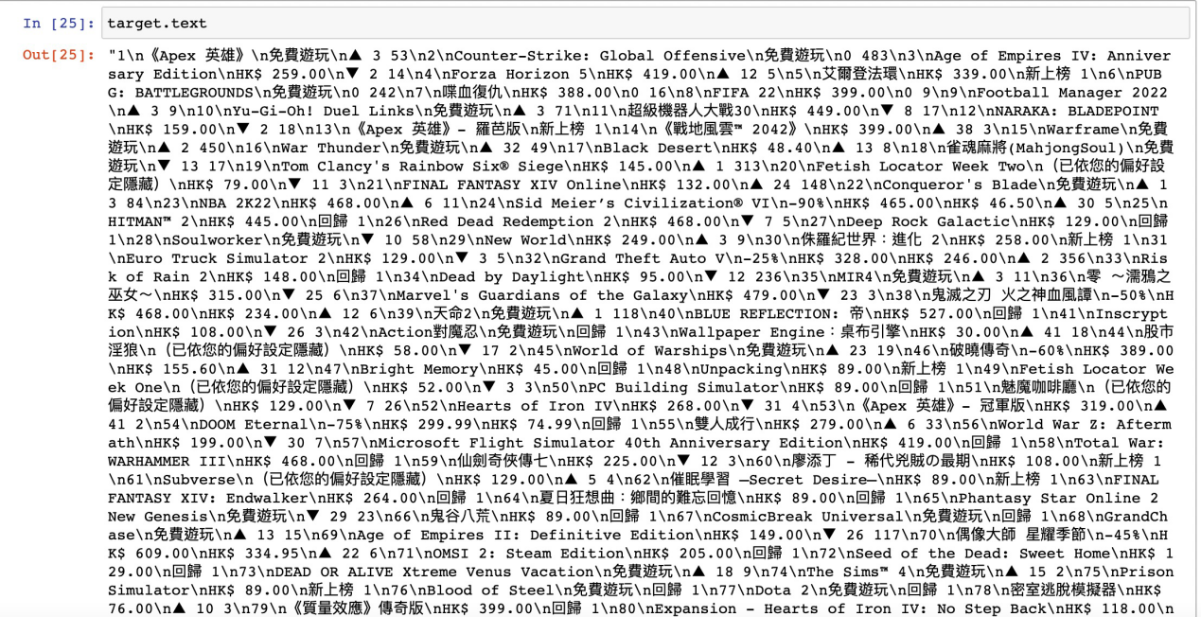

By printing out all the content, we notice that each block was divided by “/n”, so we then use “backslash n” to do the split:

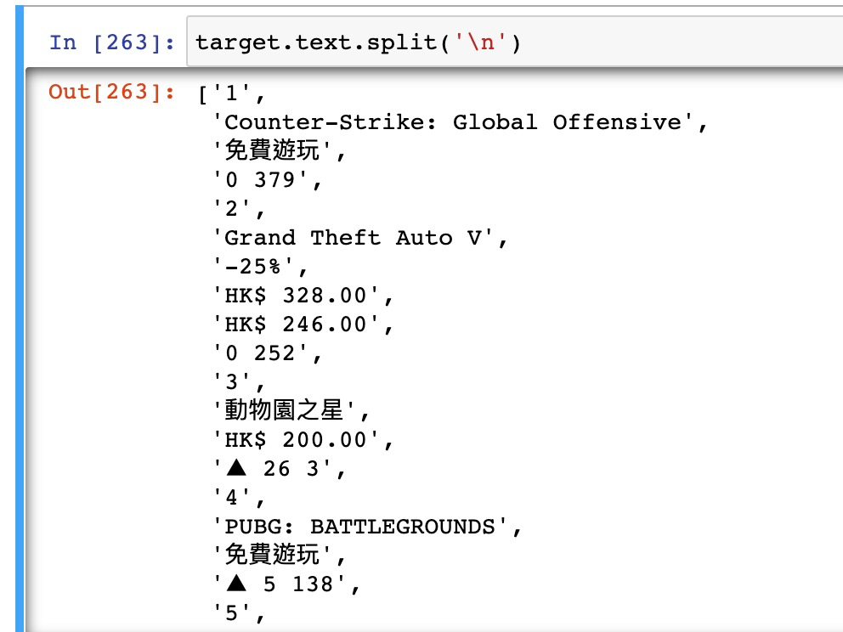

From the above we can see that the information of each game starts with its ranking number, so we will do further split in the next step.

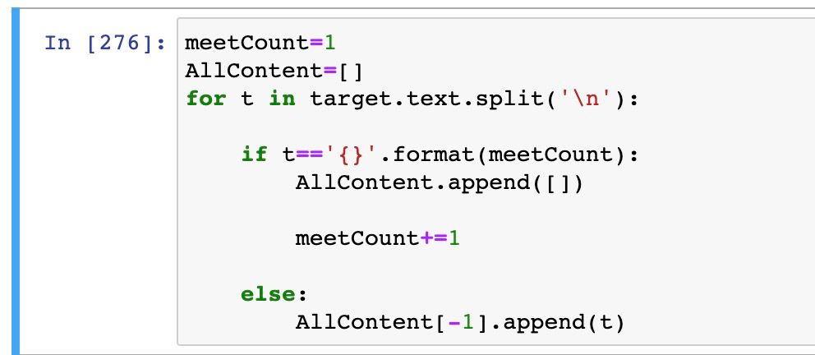

We create a for loop, which says, every time it meets a number, to create an empty list; Otherwise, to “throw” the content into the empty list we just created.

Below is what we get now, each game’s information be stored in one separate list:

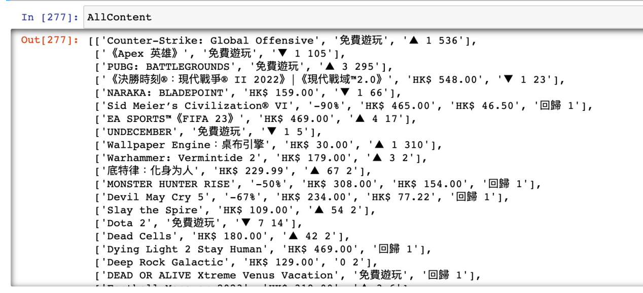

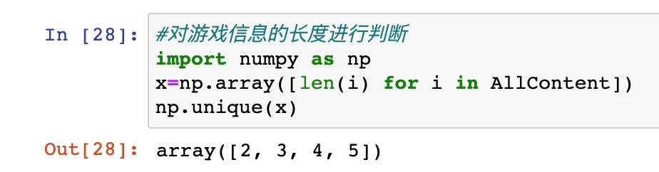

Next, we import numpy to see the number of arrays that we have in each list.

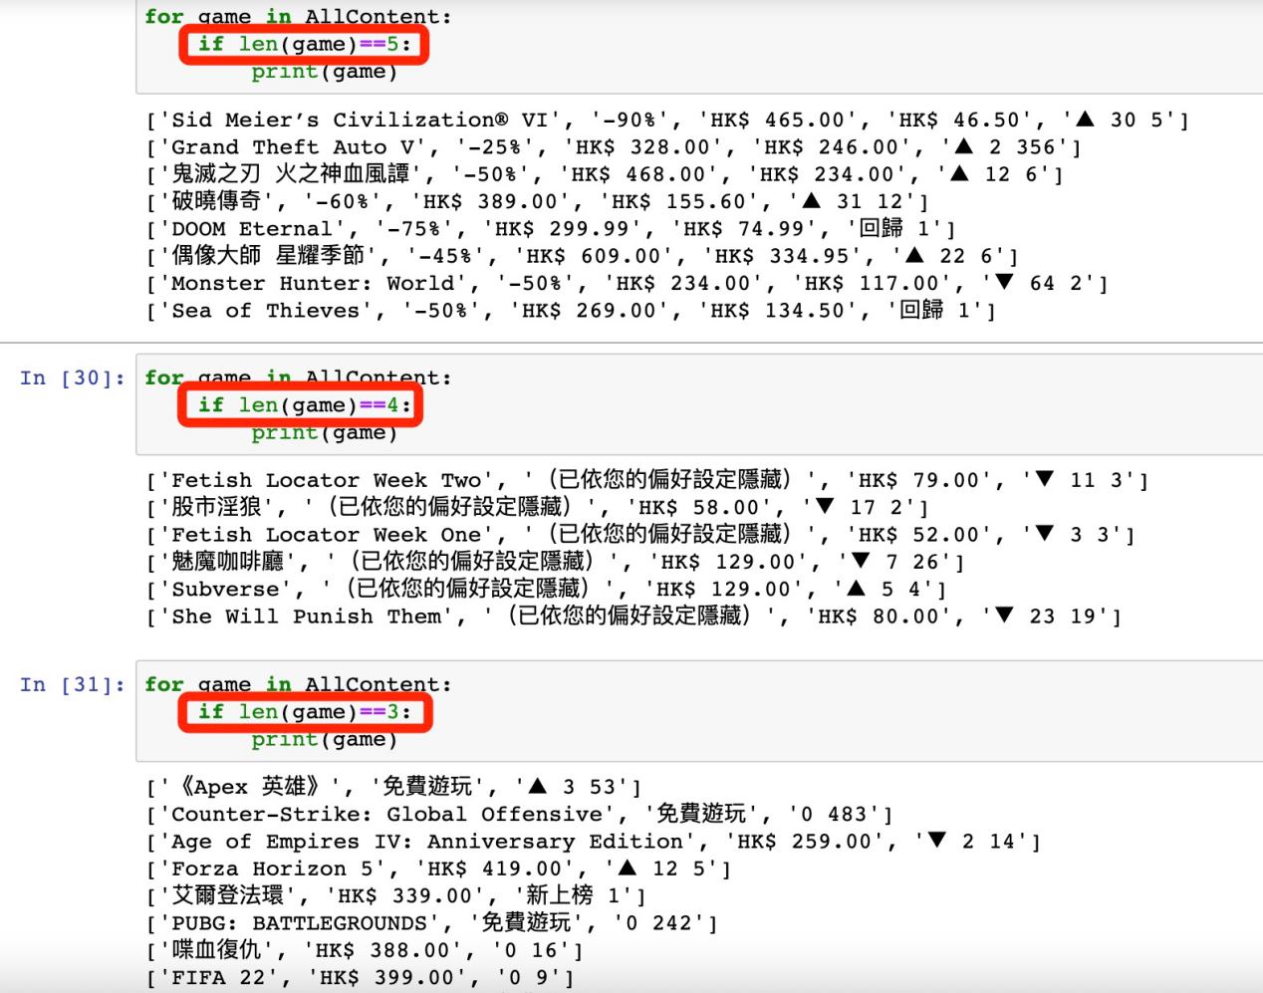

Print out different length of array to see how the content inside are arranged.

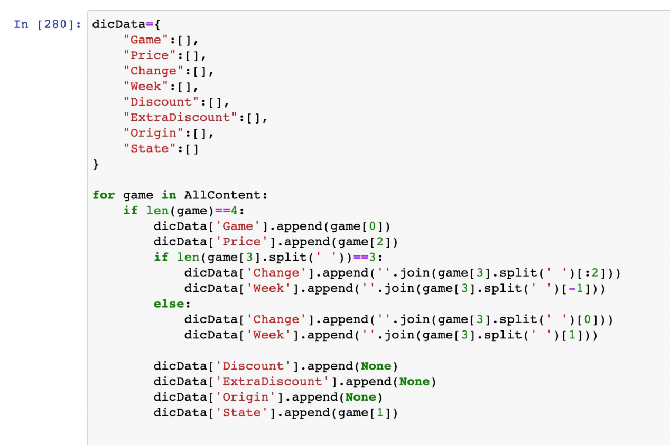

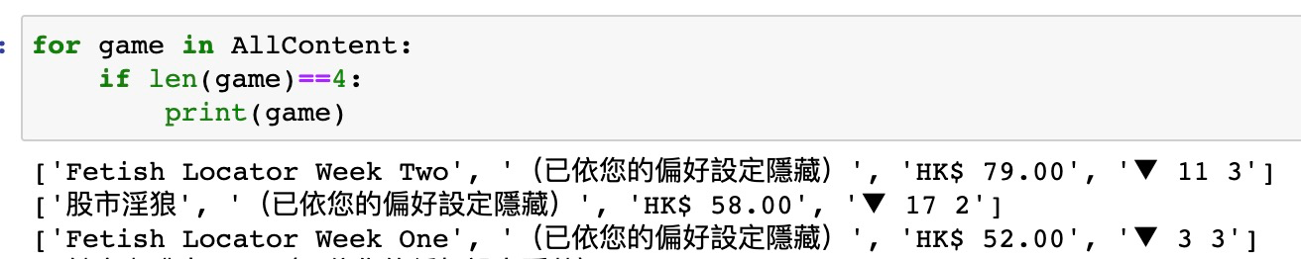

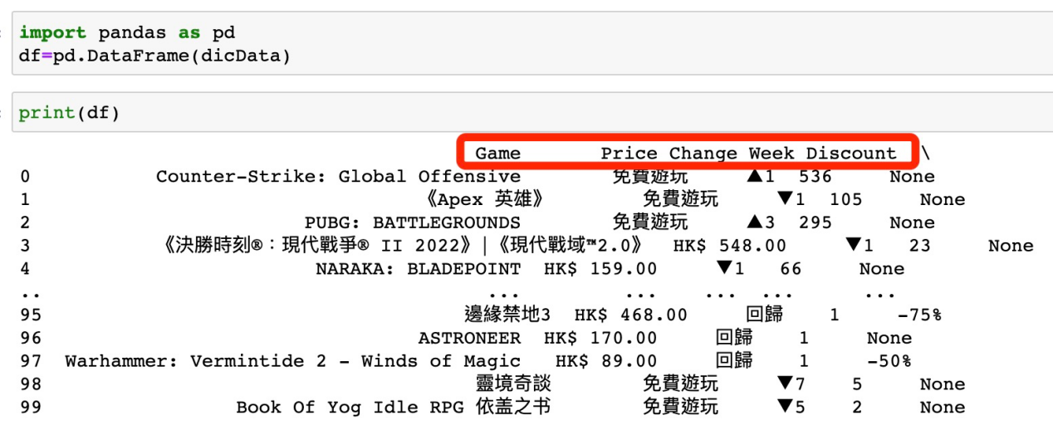

Take a look at the data we get now and to save it.

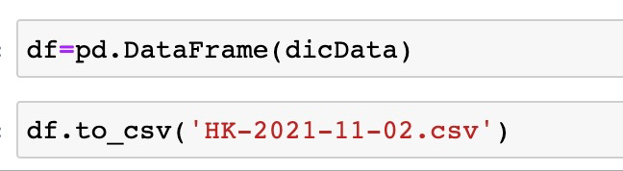

Here’s the csv data looks like:

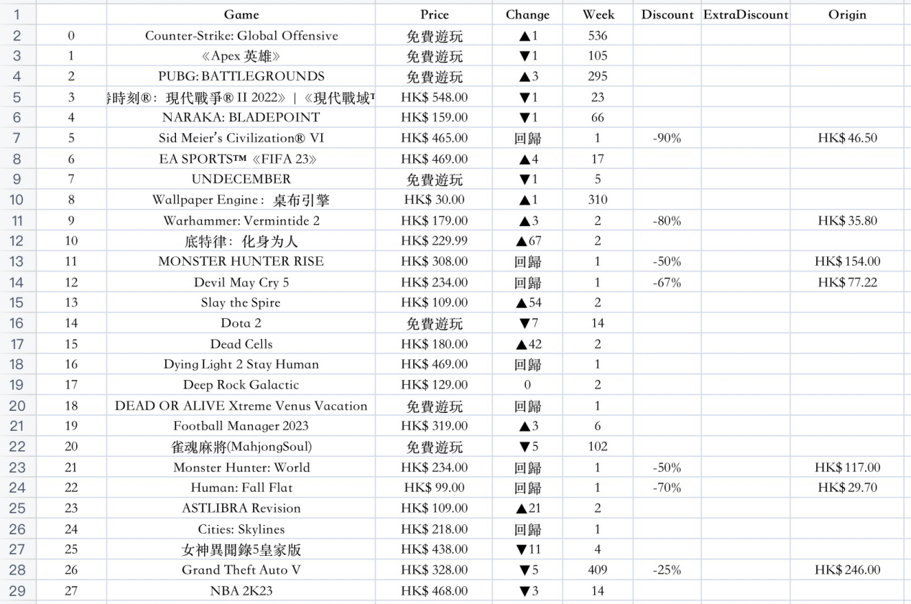

As for data visualization, we use Excel to present line chart.

**Figure 4**

*Popular trends in mainland China from 2019～2022*

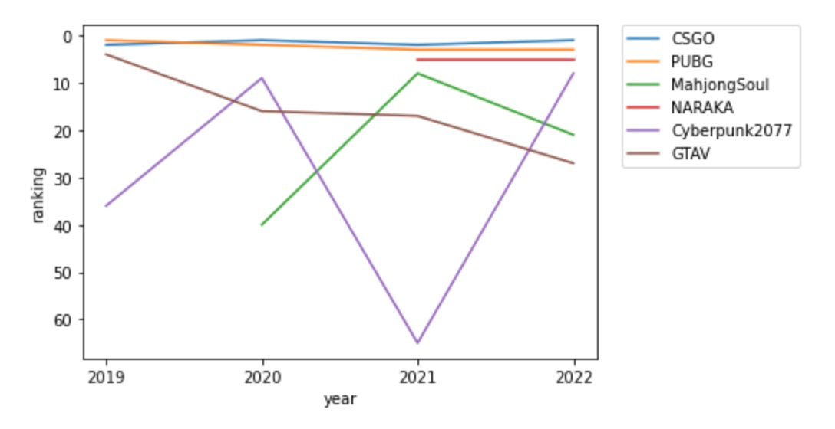

From the line chart above we can see that CSGO and PUBG have been doing good in the past 4 years. While NARAKA, which is produced by Netease, poped up into our sight after it was released in 2021. What is also worth our attention is, Mahjong Soul had gain much more popularity after the outbreak of the COVID-19 pandemic. Also, Cyberpunk2077 has been brought back to life after its derivative animation, Cyberpunk Edgerunners achieved great success worldwide.

**Table 2**

*Top 10 popular games 2022 in different regions*

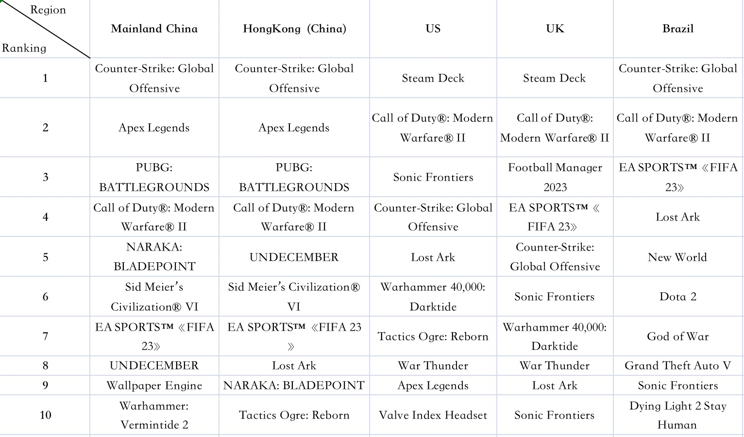

HongKong, as a special administrative region of China, its players share similar gaming preferences with players in mainland China. While people in the United States and in Brazil do not show special preferences for NBA2K and FIFA23, these are also interesting findings which do not match the public’s general stereotype.

## 3.3 The most popular tags on the top 100 sellers

For this part, we want to explore what tags are the most popular on the Top 100 Sellers and some basic information about game, such as name, id, tags, positive rating and so on.

However, all we can see on the top sellers page are the name, time, and price of each game. We need to open the details page for each game individually to see the rest of the details.

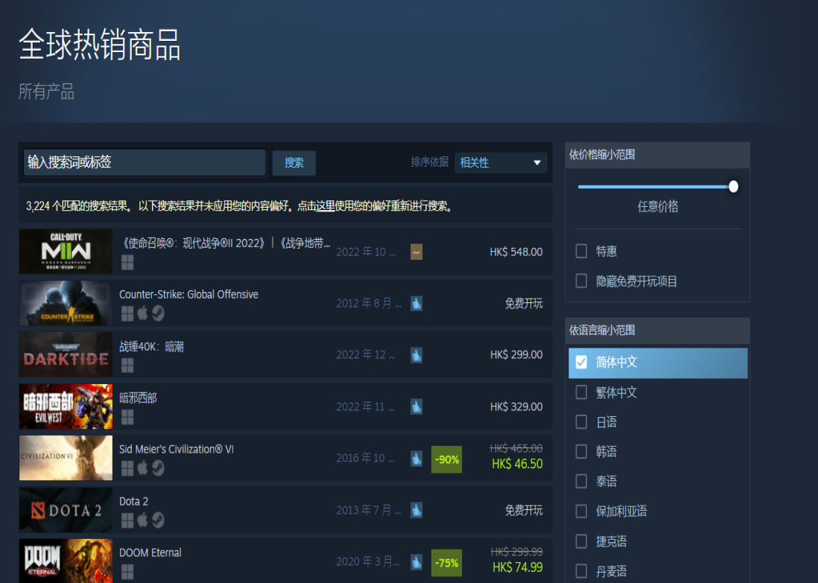

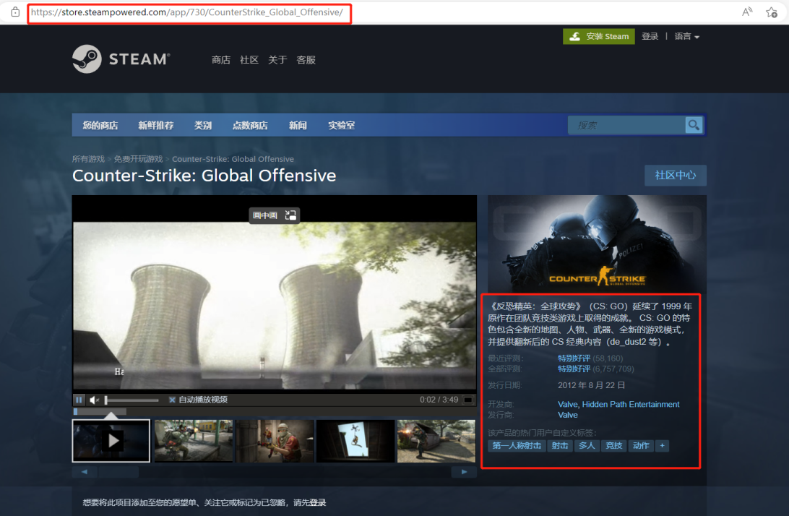

Since each game only has a unique id, we can open the detailed page of different games by changing the id numbers. Therefore, the data crawler of this part is divided into two steps.

Firstly, we used BeautifulSoup, re and Pandas to extract the game's link and ID, and then converted them to a dataframe and saved it.

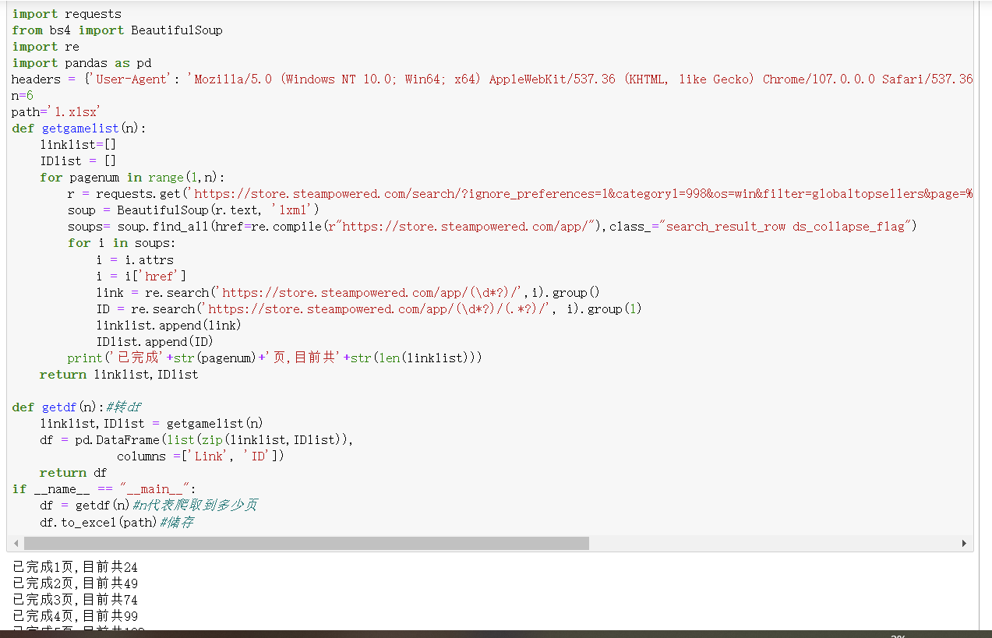

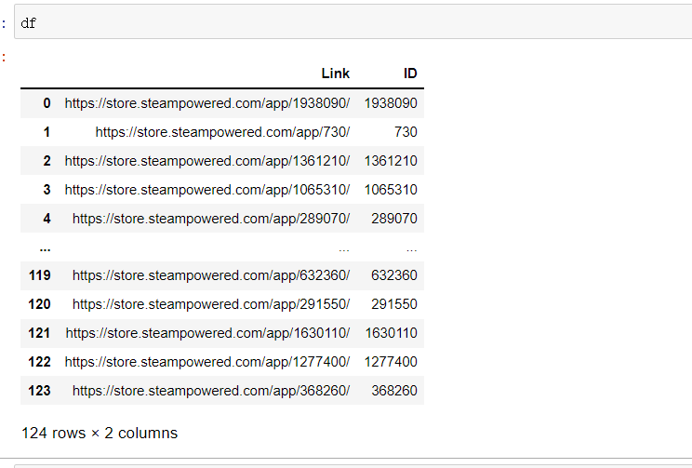

Secondly, we looked into the code for the game detail page and found the class structure of each message we wanted, then used Pandas to read the detail page for each game and input the basic information for each game.

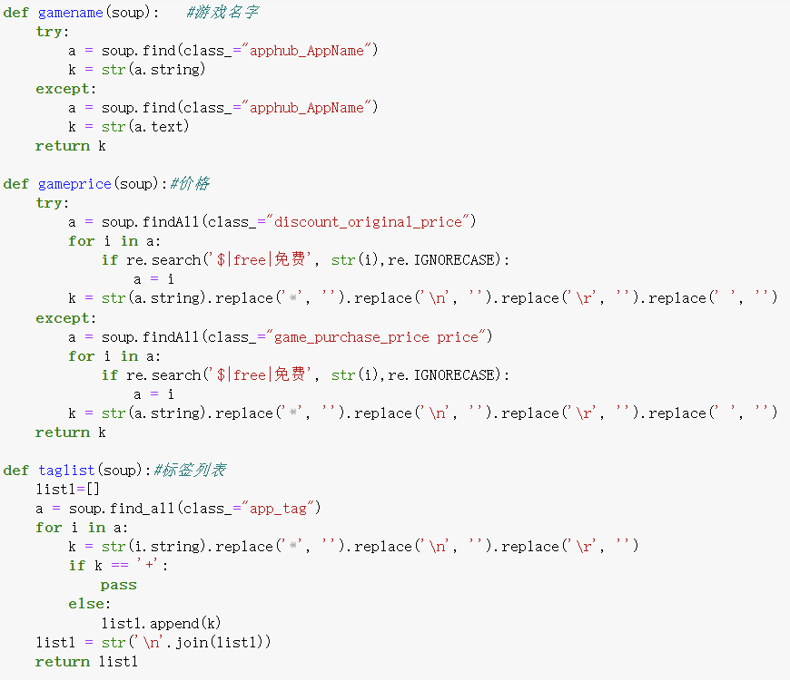

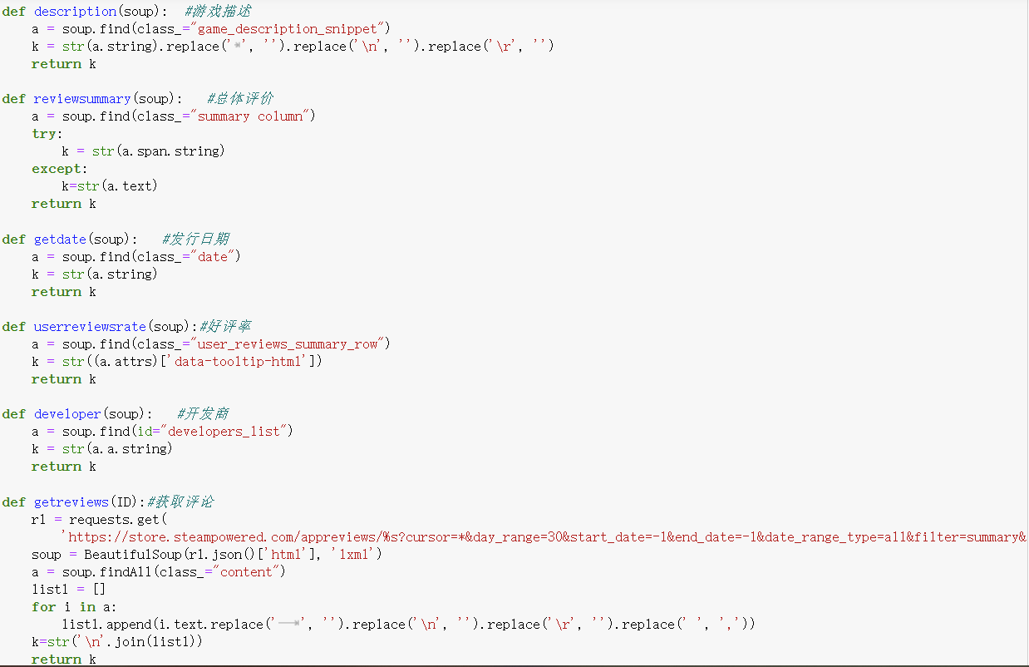

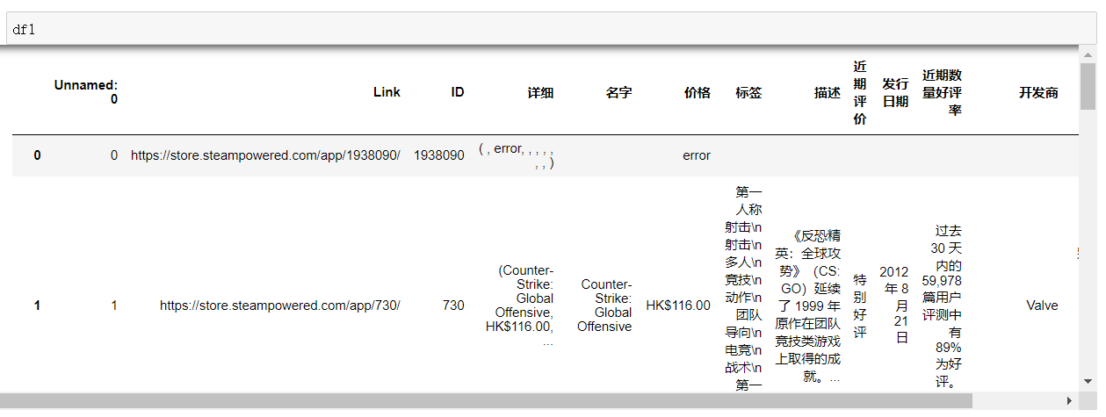

However, there is a problem with this method, because some games have age restrictions. If we want to open the game details page, we will first jump to the page of age authentication. For games with age restrictions, there will be an error in the final result, and we cannot get any information except the link and id. We tried to write some code to get around this limitation, but there were some bugs that we gave up, fortunately fewer than ten games had this problem.

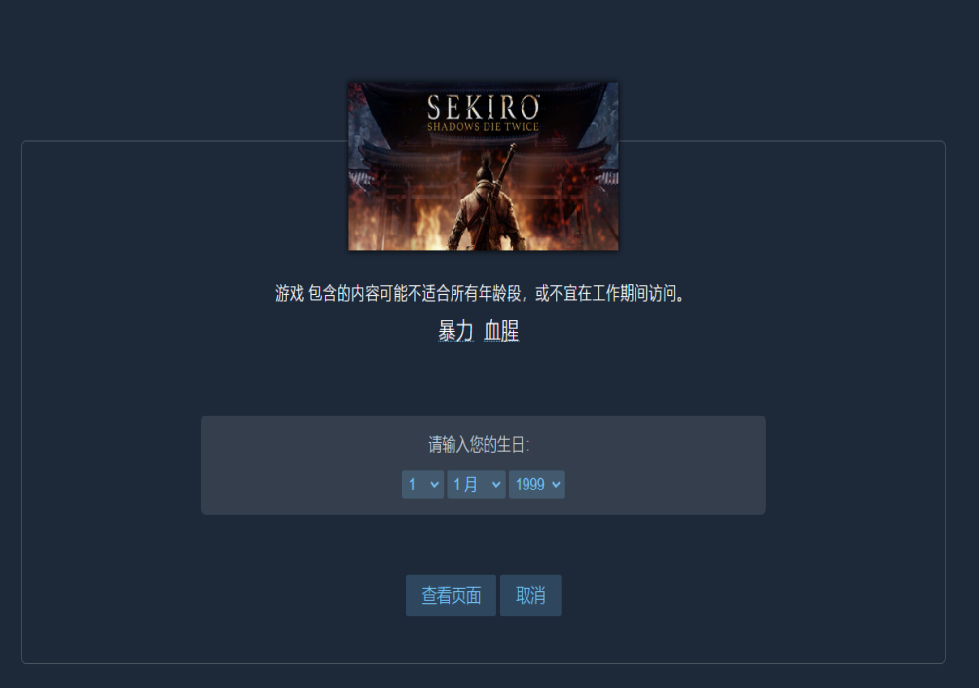

Then, we analyzed the game tags. Since there is no single game play nowadays, every game has so many tags. We selected all the tags of the top 100 games to find out which tags appear more frequently and what kind of games are the mainstream in the market.

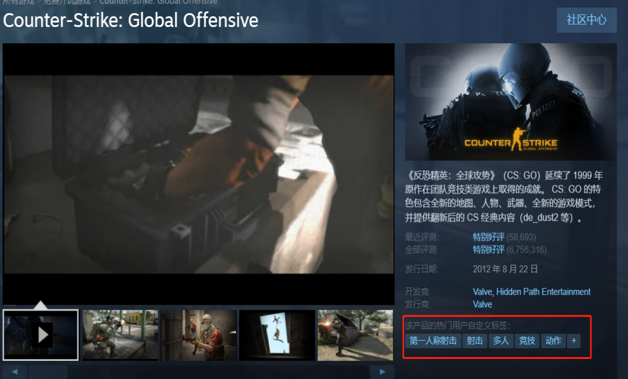

We first wrote the previous tags into the txt file and read them in python, then used jieba to divide all the words and count the number of occurrences of each word, then converted the result into a list with items and sort these words.

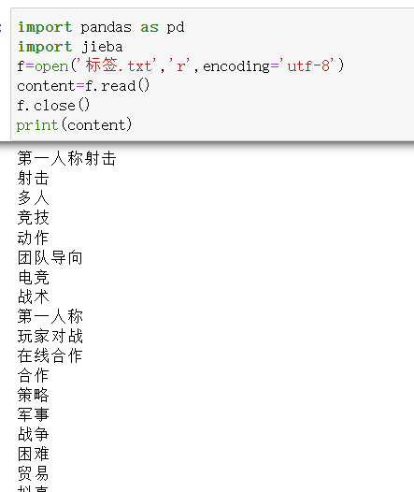

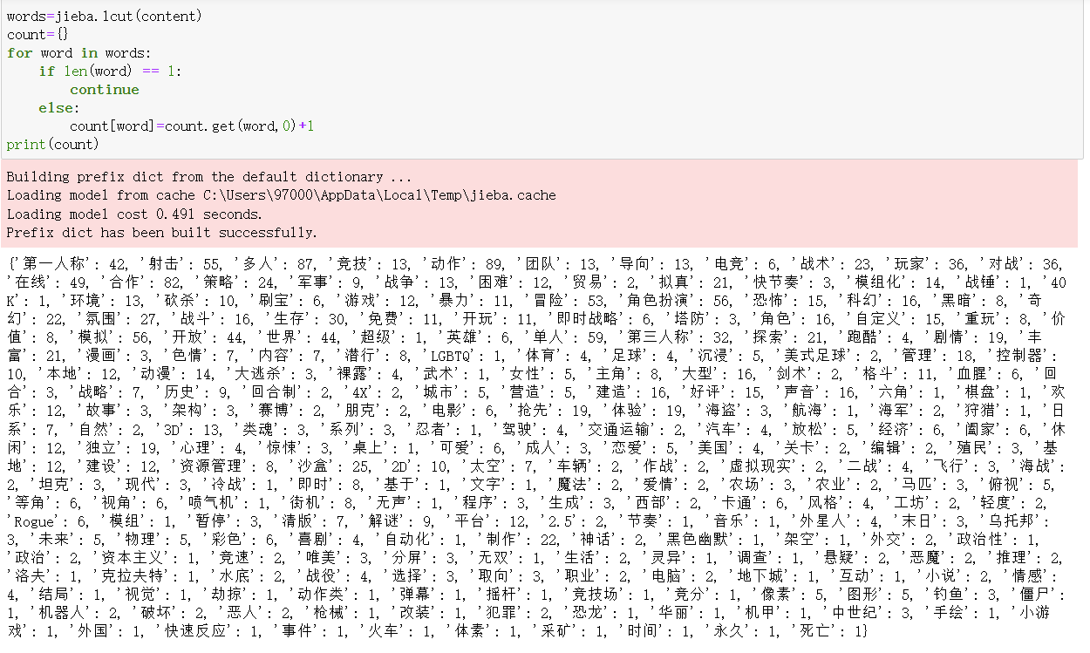

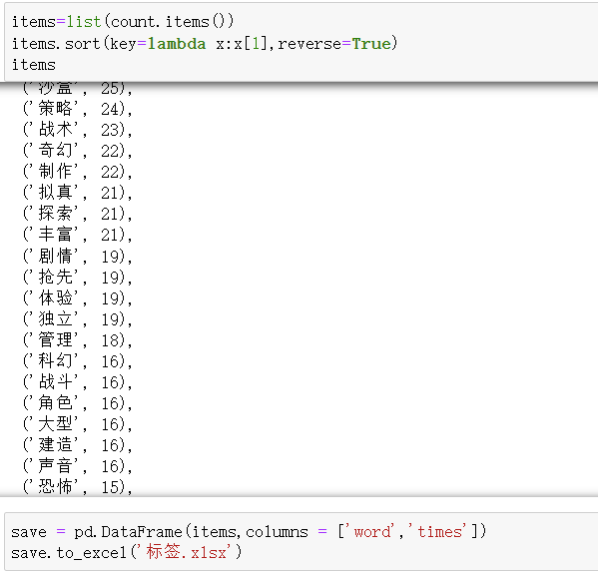

We then removed the tags that appeared less than 10 times and used the remaining tags to make a word cloud map.

**Figure 5**

*Word cloud map*



## 3.4 The relationship between the rate of reviews and the price of games

We wanted to explore the relationship between game sales and the number of reviews and comments for these hot games. Whether a hot game is more highly rated and more discussed.

We obtained the number of reviews and reviews for each hot game within 30 days directly from the home page of steam, based on the data dimensions presented by steam. As the games were released at different times, choosing the same time frame to compare the data is fair.

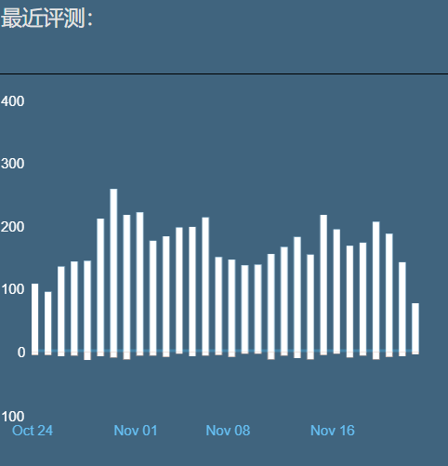

Firstly, the overall content of the positive review data has already been done in the previous data capture, so we will not repeat it here.

Secondly, the data was cleaned and separated. The rating data is presented as a string containing both rating and review data points, so extracting these two numbers from the string is essential. We used an Excel tool to split the string and recombine it.

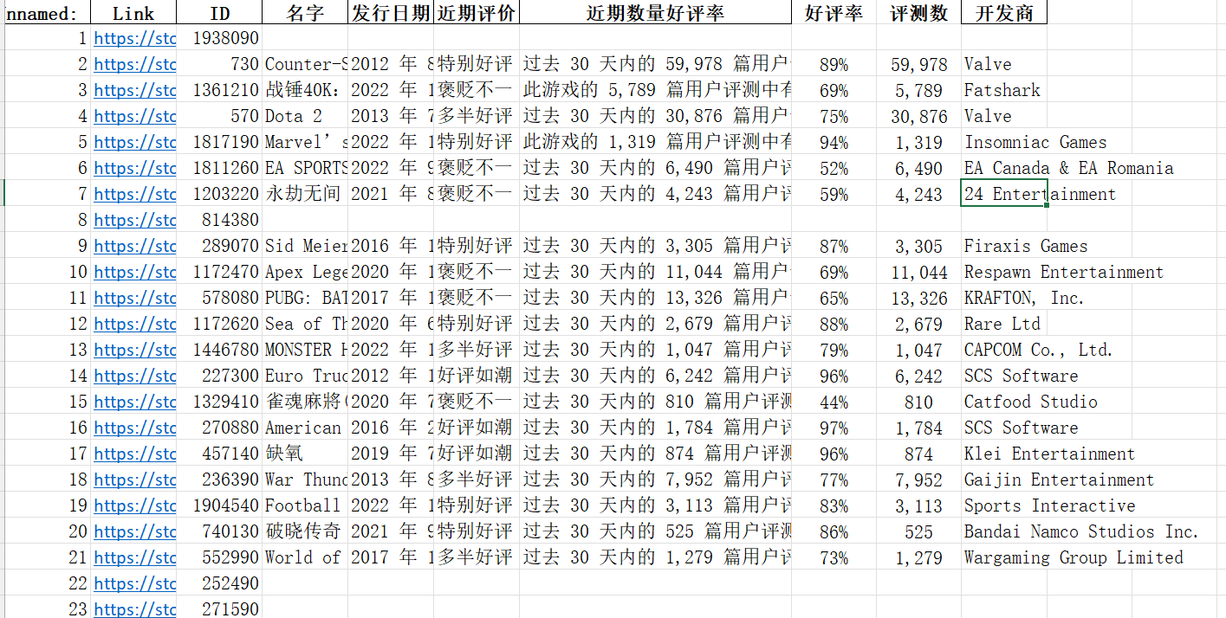

Based on this data and the variables, we used the tableau visualization tool to create a scatter plot. The horizontal axis means the number of reviews, and the vertical axis is the rate of positive reviews. The numbers represent the ranking of the game on the list.

**Figure 6**

*Scatter plot*

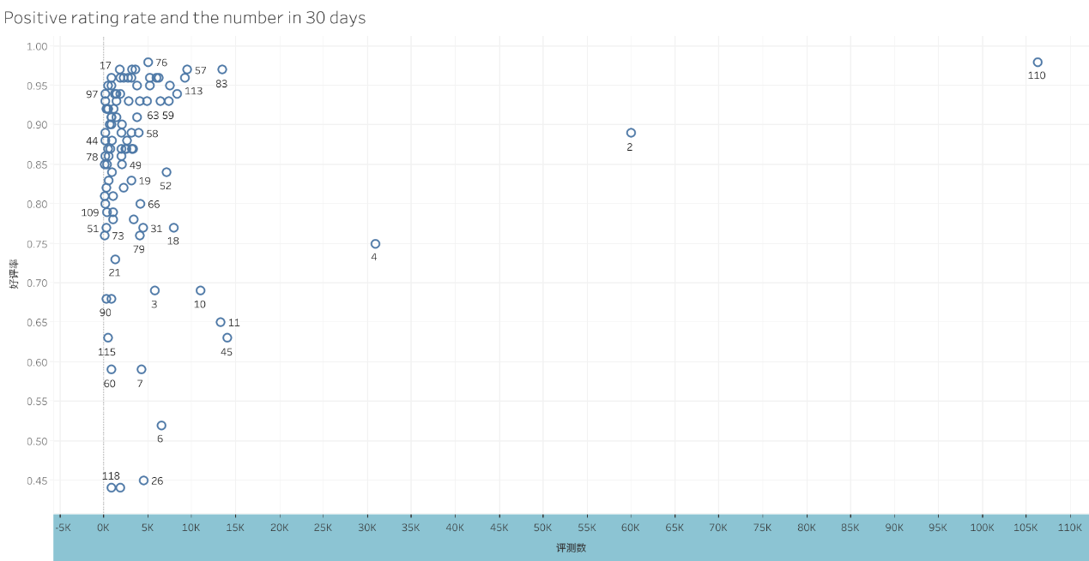

## 3.5 Keywords that appear frequently in user reviews

Next, we want to explore what people are saying when they review. To get the data, we need first to find the pages where each game's review community is located and clarify the naming convention of the pages. By examining this, we found that the logic of the review page is made up of this prefix URL plus the game id.

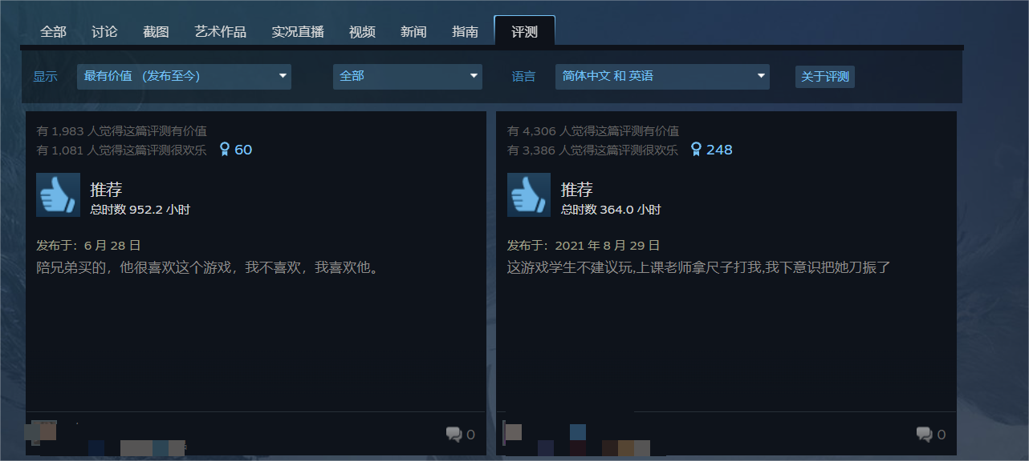

As we had already obtained the game ids, we used the requests function to access the page's content directly and obtain the required review parameters from the cursor data area of the page.

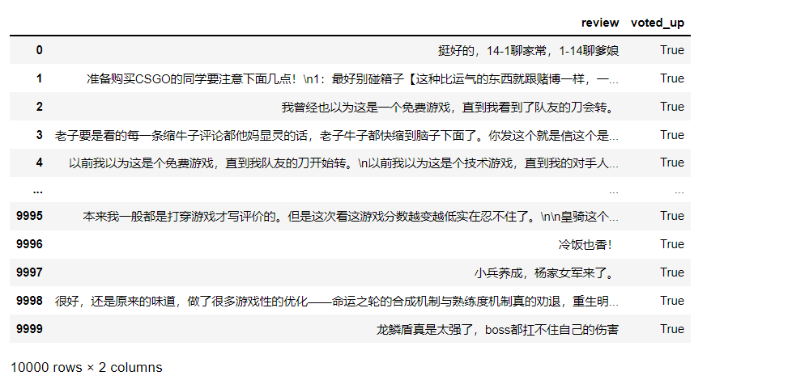

By crawling the content of the parameters, we have obtained a large number of string comments. Next, we need to clean and adjust the data content. We split the string content into words, aggregated the content into txt form, then used the jieba function to split the words.

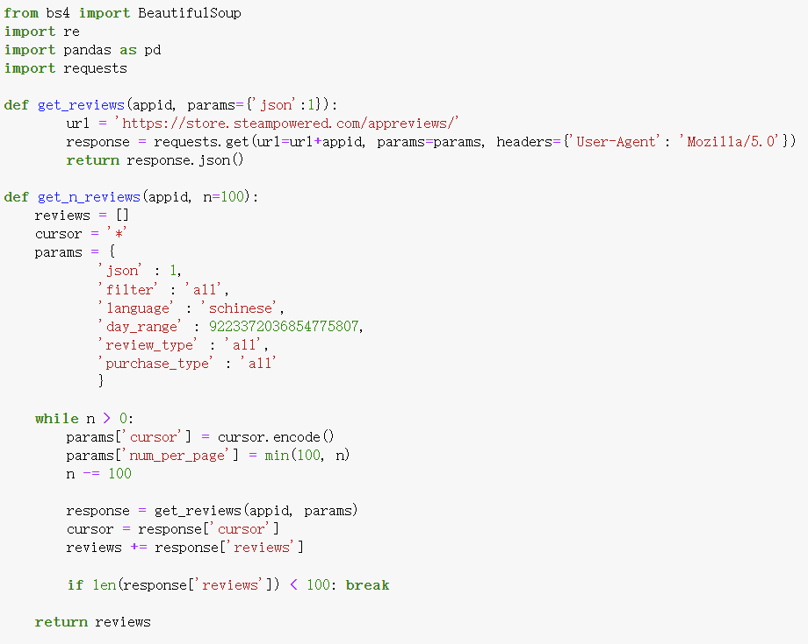

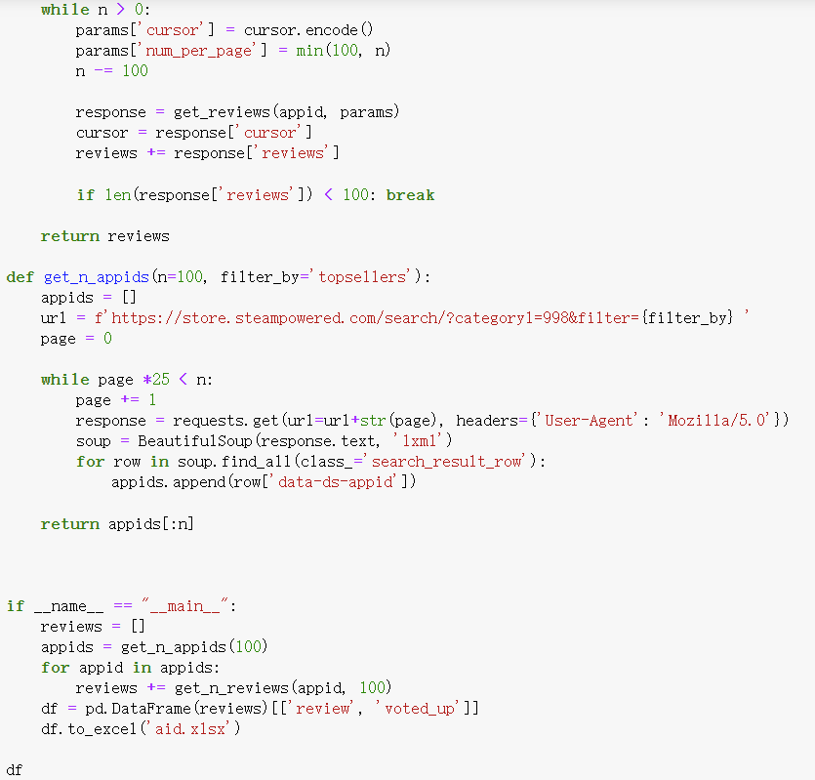

Then we used code to remove the stopwords and delete the useless content to ensure the words were clear.

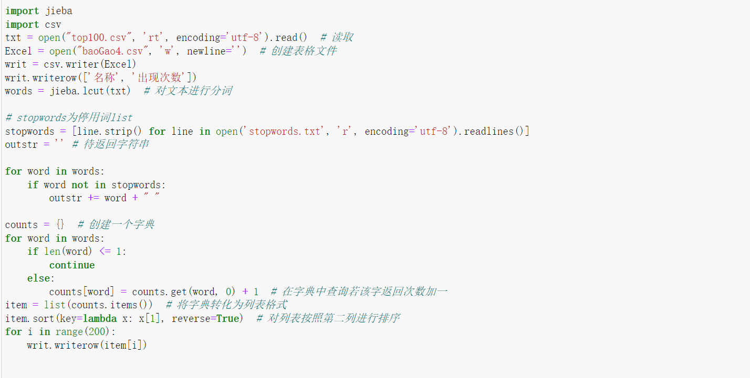

Finally, we used tableau to form a word cloud map with the words obtained and their word frequency data content. The word cloud map gives a clearer picture of the frequency of specific words and highlights the key points we want to make.

**Figure 7**

*Word cloud map*

